# IDENTIFICACIÓN DE LA GUIA DE APRENIZAJE

* + Denominación del Programa de Formación: Bilingüismo
  + Código del Programa de Formación:
  + Nombre del Proyecto: Bilingüismo
  + Fase del Proyecto: Lectiva
  + Actividad de Proyecto
  + Competencia: INGLES: INTERACTUAR EN LENGUA INGLESA DE FORMA ORAL Y ESCRITA DENTRO DE CONTEXTOS SOCIALES Y LABORALES SEGÚN LOS CRITERIOS ESTABLECIDOS POR EL MARCO COMÚN EUROPEO DE REFERENCIA PARA LAS LENGUAS.
  + Resultados de Aprendizaje Alcanzar:

240202501-1. Comprender información básica oral y escrita en inglés acerca de sí mismo, de las personas y de su contexto inmediato en realidades presentes e historias de vida.

240202501-2. Describir a nivel básico, de forma oral y escrita en inglés personas, situaciones y lugares de acuerdo con sus costumbres y experiencias de vida

* Guía: 16 to 20 hours.

# PRESENTACION

Esta guía de aprendizaje propone una serie de actividades que articulan el contenido práctico del inglés con el requisito técnico de su carrera y las estructuras gramaticales sugeridas, vinculando un inglés general con uno técnico. De esta manera, se fundamenta en lograr un aprendizaje significativo y en un proceso que integre múltiples habilidades que les permitan a los aprendices desenvolverse en ambientes laborales.

# FORMULACION DE LAS ACTIVIDADES DE APRENDIZAJE

* 1. **Actividades de reflexión inicial:**

Pronunciation and phonetics tips: Intro to help apprentices to communicate more effectively in simple tasks and formulate an effective input and output for all kind of messages, with proper phonetic rules, we can improve the connection between written messages and oral discourses. In that way, we comprehend better the oral messages as well as produce better content.



* *Pronunciaton tips: sound /ge/*
* *Pronunciaton tips: sound /* dʒ*/*

Si el sonido de la palabra no es pronunciado correctamente podría causar confusiones y malentendidos ya que el receptor entendería incorrectamente.  La pronunciación correcta nos da confianza para poder conversar y nos ayuda a entender mejor a los nativos, además de mejorar la entonación y una comunicación efectiva, so ¡let’s start with basic pronunciation tips!

***Sound /ge/ with the reading ‘ What’s renewable energy?’***

***ACTIVITY: -*** *Evidence pronunciation /ge/: Solve the exercise and send the screenshot with the final result, Click on:* [*https://www.spellzone.com/word_lists/games-286737.htm*](https://www.spellzone.com/word_lists/games-286737.htm)

Brief phonetic intro to develop oral skills. We will practice with the words with the *sound* ***/ge/***: class practice:[*https://wordwall.net/resource/10775124*](https://wordwall.net/resource/10775124)

[*https://es.educaplay.com/recursos-educativos/7239877-the_ge_sound.html*](https://es.educaplay.com/recursos-educativos/7239877-the_ge_sound.html)

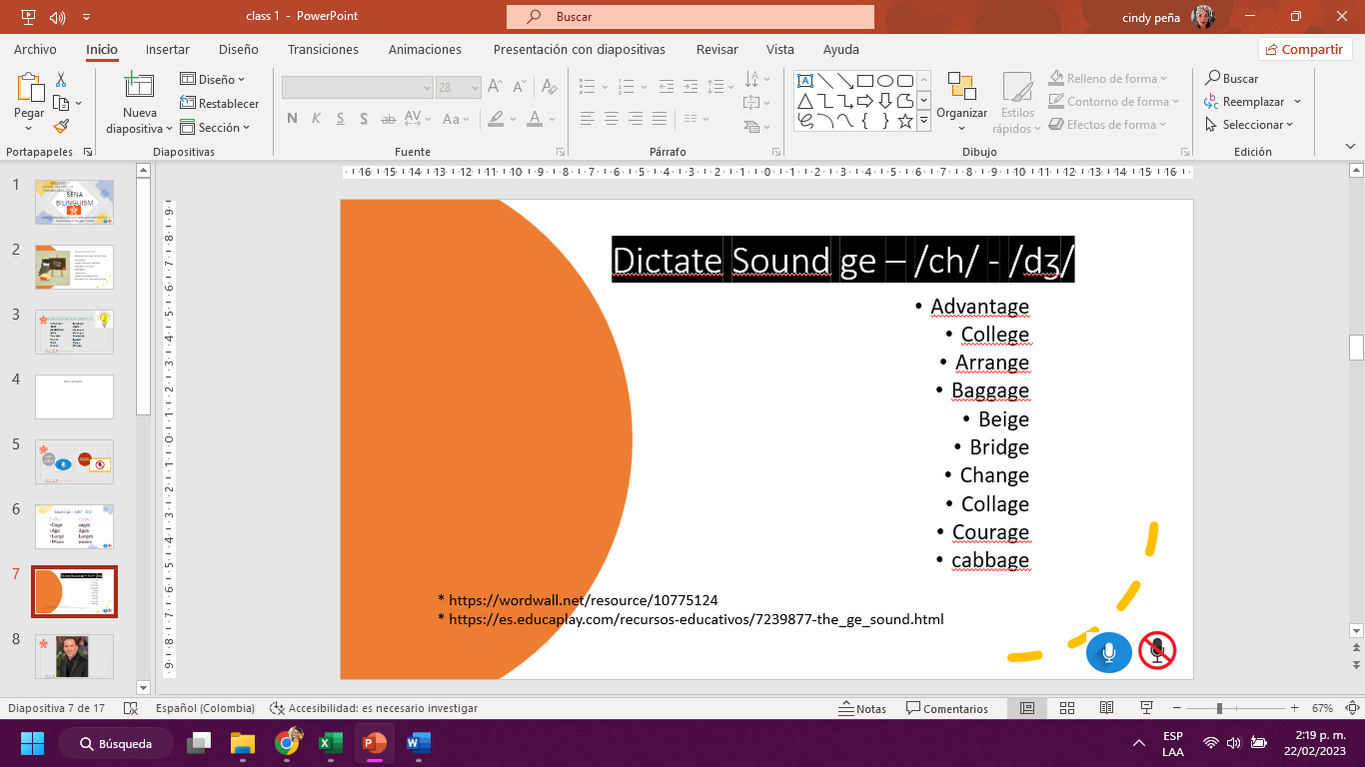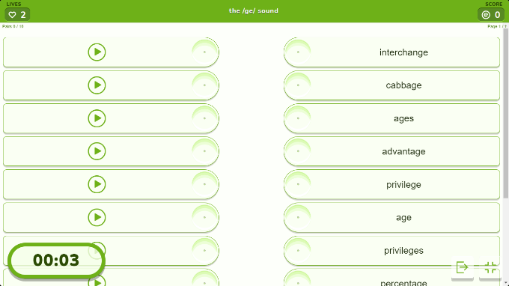

***Basic commands in English***

Los hablantes nativos del inglés aman usarlos durante una conversación, y frecuentemente los encuentras en libros y en shows de televisión. Para perfeccionar tu inglés, debes tener más confianza en el uso de los idioms y saber la diferencia entre *break a leg*y *pull someone’s leg.*

Every language has its own **idioms** and **expression** and the English language has plenty of phrases that is useful to learn. Idioms are words or phrases that aren’t meant to be taken literally and usually have a cultural meaning behind them. There are some of them that are more popular than others that will come handy if you know them. When you learn English idioms and phrases you will sound more confident especially when you speak with native English speakers.

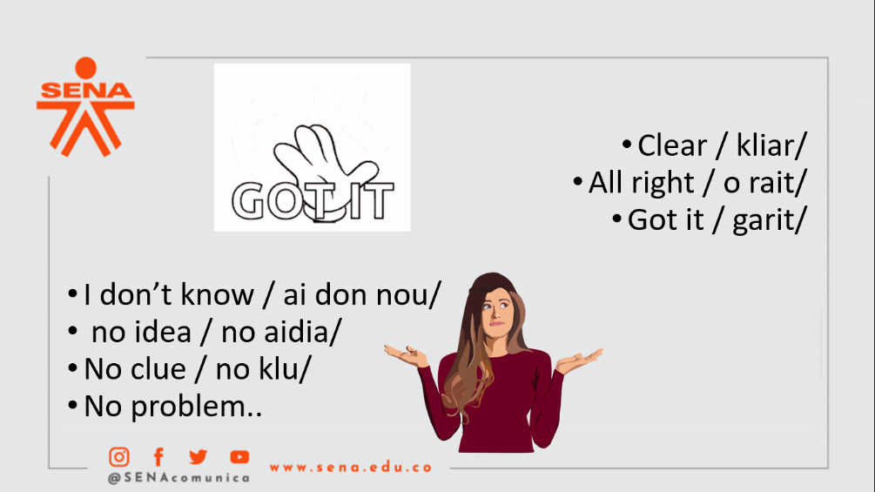

**3.2 Actividades de contextualización e identificación de conocimientos necesarios para el aprendizaje**

Reading practice to develop reading comprehension, technical vocabulary related to the Industrial electricity area and oral skills like fluency in speaking. Apprentices will also learn how to introduce themselves and give basic info about their profession. They will record themselves as evidence for Territoriumm or Classroom:

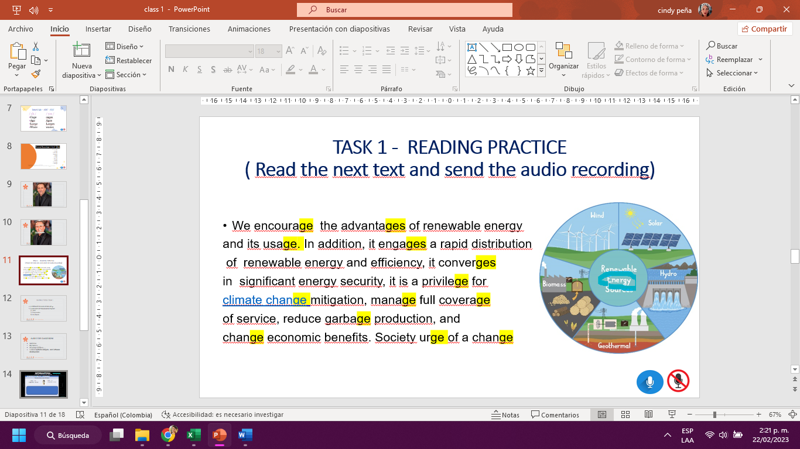

**Basic Greetings**

A greeting is one of the basic functions of communication and triggers positive conversations. Greetings are the first thing you learn in any new language, the basic sign of welcome that shows your intent to talk to someone.

EMOTIONS VOCABULARY: Emotions vocabulary words can be really important in describing how we feel and how others are feeling. Most of us know the emotional states happy and sad, but what about determined and resentful?  We will practice a list of words to expand your vocabulary.

Speaking practice: Brief conversation practice with 3- elements, each element represents a part of the conversation. Apprentices are organized in groups of 3 and practice the short conversation:

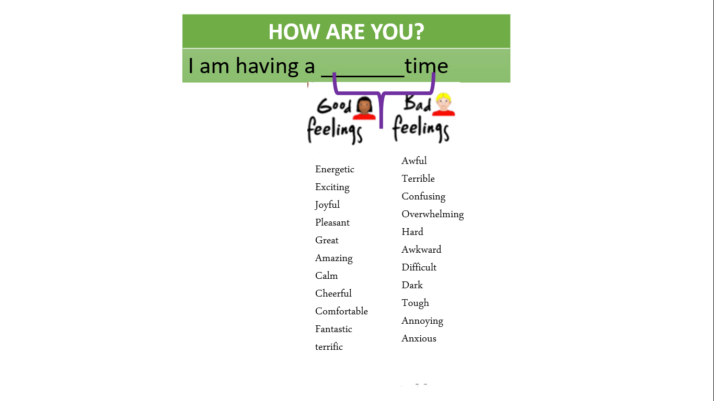



**3.3. Actividades de apropiación del conocimiento (Conceptualización y Teorización).**

1). PRE-READING: Scan the document, then identify new vocabulary.

Scan the document to identify the -ge sound

2). READING: Read the document and identify the most important idea of each paragraph. Then

record yourself reading your own review aloud and using the words with the /-ge/ sound. (assessment)

3). POST-READING: After the students have finished reading the text, fill up the table applying the affirmative, negative, and interrogative form of the present simple.

**WHAT IS RENEWABLE ENERGY?**

We encourage the advantages of renewable energy and its usage. In addition, it engages a rapid distribution of renewable energy and efficiency, it converges in significant energy security, it is a privilege for [climate change](https://www.myenglishpages.com/site_php_files/reading-climate-change.php) mitigation, manage full coverage of service, reduce garbage production, and

change economic benefits. Society urge of a change

Software engineers manage to develop sustainable software that is environmentally friendly. Software programmers reduce climate change damages when they: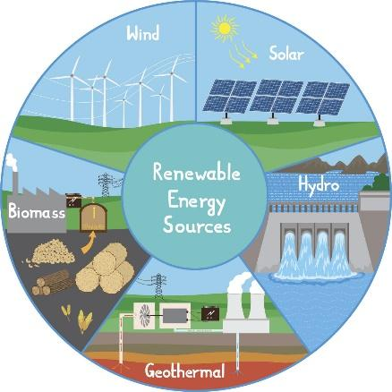

* Design Sustainable software to minimize the impact

on the environment.

* Create software that uses fewer resources.
* Develop software that reduce the percentage of power consumption
* Develop software for low-power devices like smartphones and tablets.

**Some examples of Software programmers impact:**

* Software engineers use virtualization technologies to reduce the number of physical servers required.
* Software engineers   move applications and data to the cloud and reduce energy consumption
* Software developers participate in large events about climate innovative solutions.
* Software engineers help develop climate models to predict future weather patterns.
* Developers engage in policy discussions about legislation for sustainable software practices.

Renewable energies manage to lift the poorest nations to new levels of prosperity. Besides, renewable energy encourages electrification, which has several benefits.

POST-READING: Fill up the table applying the affirmative, negative, and interrogative form of the present simple. For the affirmative and negative answers apply the yes/ no table***: Look at the first example:***

| QUOTE FROM THE TEXT | FORM |
| --- | --- |
| We encourage to use Renewable energy | Interrogative: *Do we encourage to use Renewable energy ?* |
| Affirmative:***yes,*** *We encourage to use Renewable energy* |
| Negative:***No,*** *We don’t encourage to use Renewable energy* |
| Software programmers reduce climate change damage | Interrogative: |
| Affirmative: |
| Negative: |
| Software engineers manage to develop sustainable software | Interrogative: |
| Affirmative: |
| Negative: |
| They develop software for low-power devices | Interrogative: |
| Affirmative: |
| Negative: |
| Developers engage in policy discussions | Interrogative: |
| Affirmative: |
| Negative: |
| Renewable energies manage to lift the poorest nations | Interrogative: |
| Affirmative: |
| Negative: |
| greenhouse gasses create climate changes | Interrogative: |
| Affirmative: |
| Negative: |
| *Your own example taken from the text* | Interrogative: |
| Affirmative: |
| Negative: |

***ACTIVITY:***

Learning how to make questions in English is really important, they help us engage in meaningful conversations, so we will practice by making simple yes/no questions. We use **do/does** or as question words when we want to ask  questions about actions. We use does and is with third person singular pronouns (he, she, it) and with singular noun forms.

We will start by practicing with DO and everything related to VERBS present simple.

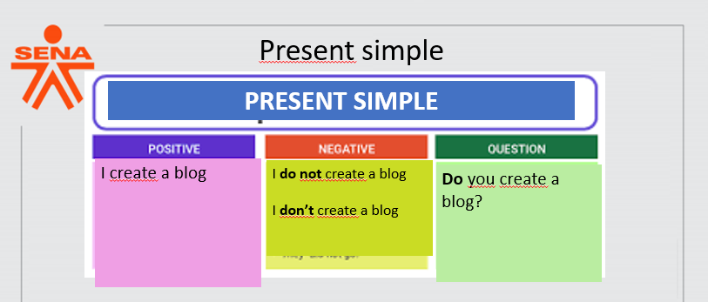

*Verbs Practice 1:* <https://wordwall.net/es/resource/53402489/yes-no-questions-in-present-simple>

*Verbs Practice 2:* <https://quizlet.com/co/884052021/verbs-vocabulary-practice-flash-cards/?funnelUUID=afb0e662-6afb-4958-8037-335d49ba5167>

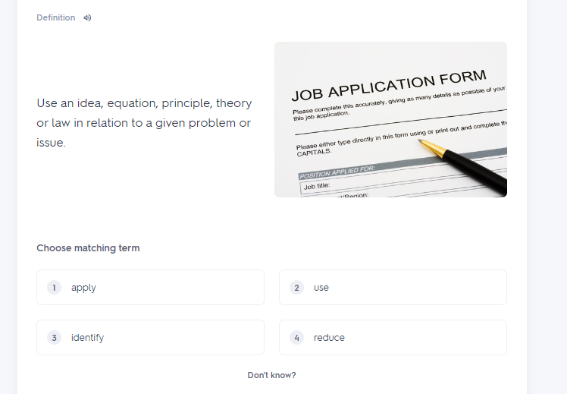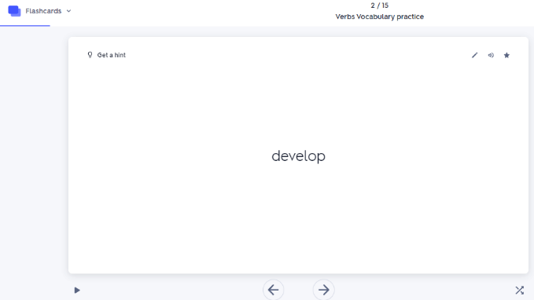

*Making questions in simple present and answering. Solve the next exercise:*

<https://agendaweb.org/exercises/verbs/present/do-does-1>

*Once you finish, send the screenshot and give your real answers, using the yes / no table*

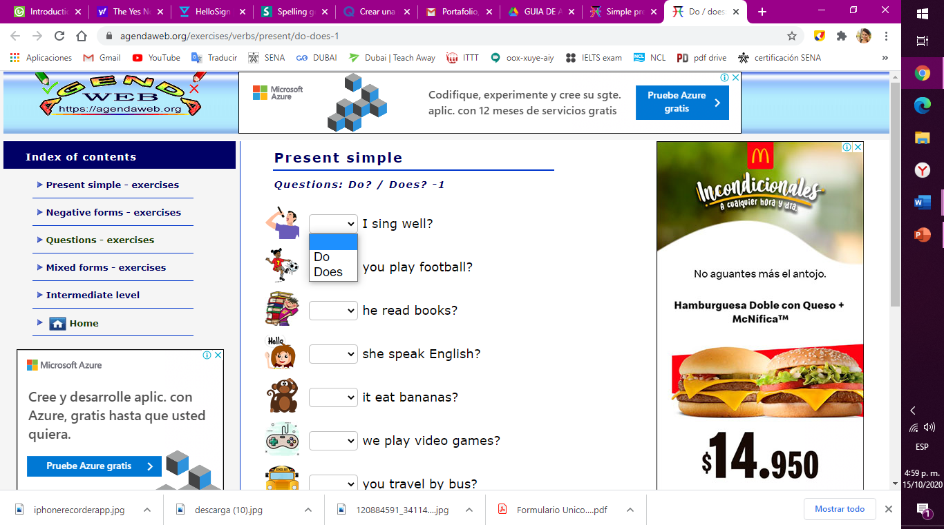

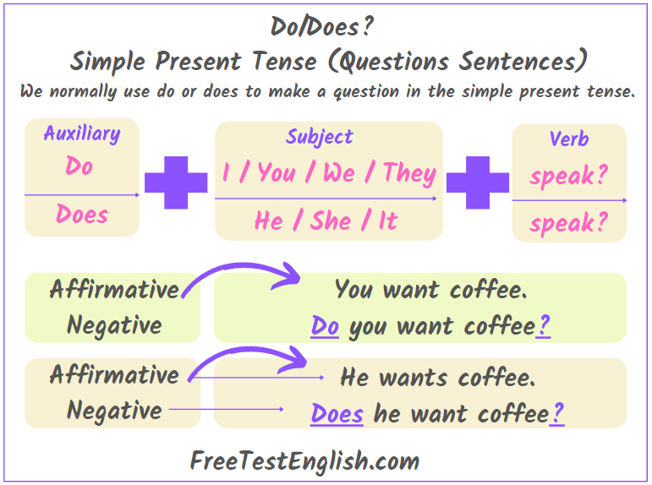



Links of practice:

* <https://www.liveworksheets.com/w/en/english-second-language-esl/278713>
* <https://agendaweb.org/exercises/verbs/present/do-does-1.htm>
* <https://es.islcollective.com/espanol-ele-video-lecciones/comprension-auditiva/comprension-auditiva-basica-comprobacion-de-la-audicion/tiempos-verbales/video-lesson-do-or-does/447338>
* <https://wordwall.net/es/resource/18877114/present-simple-3rd-person>

**3.4. Actividades de transferencia de conocimiento (ACTIVIDADES DE EVALUACIÓN):**

FINAL ASSESSMENT: Deliver an oral presentation by couples, you will present a dialogue to the instructor using the general and technical vocabulary seen in class, you can help yourself with this extra vocabulary.

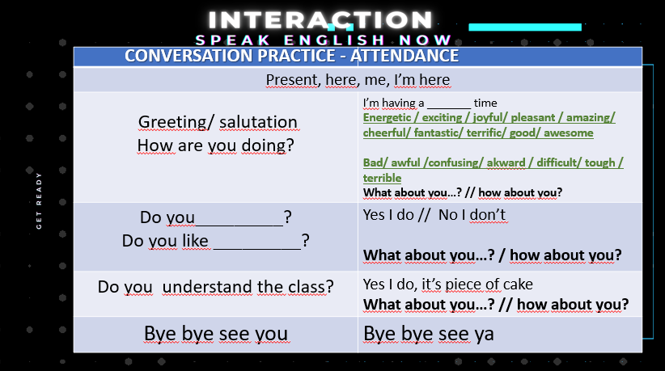

ACTIVIDADES DE EVALUACIÓN

| **Evidencias de Aprendizaje** | **Criterios de Evaluación** | **Técnicas e Instrumentos de** |
| --- | --- | --- |
| **Evaluación** |
| **Evidencias de Conocimiento:** | Identificación sonido fonético inglés con su correspondiente grafía usando vocabulario relacionado con el programa técnico | **DE CONOCIMIENTO**  Ejercicios en clase y virtuales de pronunciación |
| **Evidencias de Desempeño:** | Reading text, realización de preguntas y respuestas en presente simple. Apropiación de vocabulario técnico y general. | **DE DESEMPEÑO**  Reading text  Activity 2 |
| **Evidencias de Producto:** | Realización de dialogo por parejas aplicando comprensión de lectura, fonética explicada y y uso de vocabulario en presente simple. | **DE PRODUCTO**  Assessment 1  Dialogue using questions and answers |

1. **GLOSARIO DE TERMINOS**

* **Energy**
* **Renewable energy**
* **Renewable resources**
* **Software engineers**
* **Develop**
* **Advantage, disadvantage**
* **software**
* **energy services**
* **devices**
* **software programmers**
* **developers**
* **advantage**
* **manage**

1. **REFERENTES BILBIOGRAFICOS**

* https://dev.to/brylie/the-role-of-software-engineers-in-combating-climate-change-3h34#:~:text=Software%20engineers%20can%20help%20develop,develop%20strategies%20to%20combat%20it.
* <https://www.myenglishpages.com/site_php_files/reading-renewable-energy.php>
* <https://www.youtube.com/watch?v=_XxOb1GIbiM&feature=emb_title>
* <https://open.books4languages.com/english-a1-grammar/chapter/present-simple-interrogative/>
* <https://www.ef.com.co/recursos-aprender-ingles/gramatica-inglesa/simple-present/>
* <https://www.oysterenglish.com/emotions-vocabulary.html>

1. **CONTROL DEL DOCUMENTO**

|  | **Nombre** | **Cargo** | **Dependencia** | **Fecha** |
| --- | --- | --- | --- | --- |
| **Autor (es)** | **Cindy Peña** | **Instructor** | **Bilingüismo** |  |

**8. CONTROL DE CAMBIOS** (diligenciar únicamente si realiza ajustes a la guía)

|  | **Nombre** | **Cargo** | **Dependencia** | **Fecha** | **Razón del Cambio** |
| --- | --- | --- | --- | --- | --- |
| **Autor (es)** |  |  |  |  |  |